EXPERIMENT-2

NAME: Nishanth B ROLL NO:240701364

Aim:
To create a sample application in Zoho Creator, create a form, report, and dashboard, and explore the Develop, Deploy, and Manage sections of the Zoho Creator platform.

Setting up Zoho Creator:
- Create the Sample Application Procedure:
  - Logged in to Zoho Creator.
  - Clicked Create New Application.
  - Selected From Scratch.
  - Entered the application name as Sample.
  - Clicked Create.

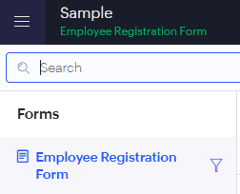

Creating Form Procedure:
  - Clicked Create → Form.
  - Entered the form name as Employee Details.
  - Added the required fields such as Name, Emp_Number, Dept, Email, and Phone.
  - Saved the form.
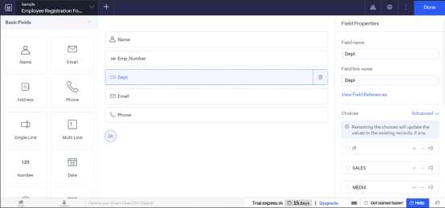

Explanation:
A form is used to collect information from users. It contains various input fields where users can enter data. The submitted data is stored in the application's database.

Creating Report Procedure:
  - Clicked Create → Report.
  - Selected the Employee Details form.
  - Created the report and saved it.
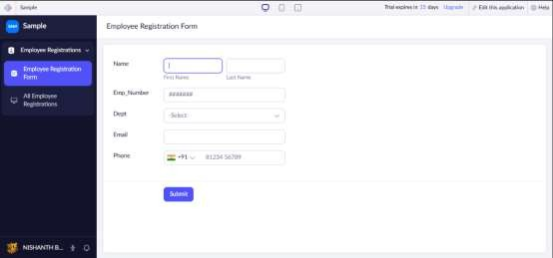

Explanation:
A report displays all the records entered through the form. It helps users search, sort, filter, and manage the stored data efficiently.

Creating Dashboard

Procedure:
  - Clicked Create → Dashboard.
  - Added report/chart components.
  - Saved the dashboard.
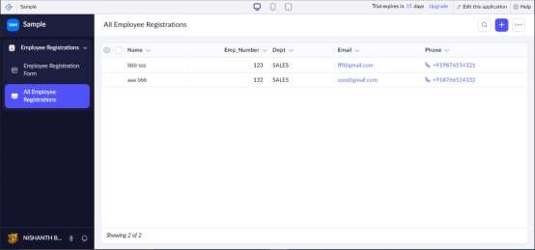

Explanation:
A dashboard provides a graphical overview of application data. It combines reports and charts in a single page, making it easier to analyze information quickly.

Exploring the Platform Architecture and Interface Develop
  - The Develop section is used to build applications.
  - It allows users to create forms, reports, pages, and workflows.
  - It also supports application customization using Deluge scripting.

Deploy
  - The Deploy section is used to publish applications.
  - It allows sharing applications with users securely.

  - User roles and permissions can also be configured here.

Manage
  - The Manage section is used to administer the application.
  - It helps manage users, backups, and integrations.
  - It also monitors application performance and security.

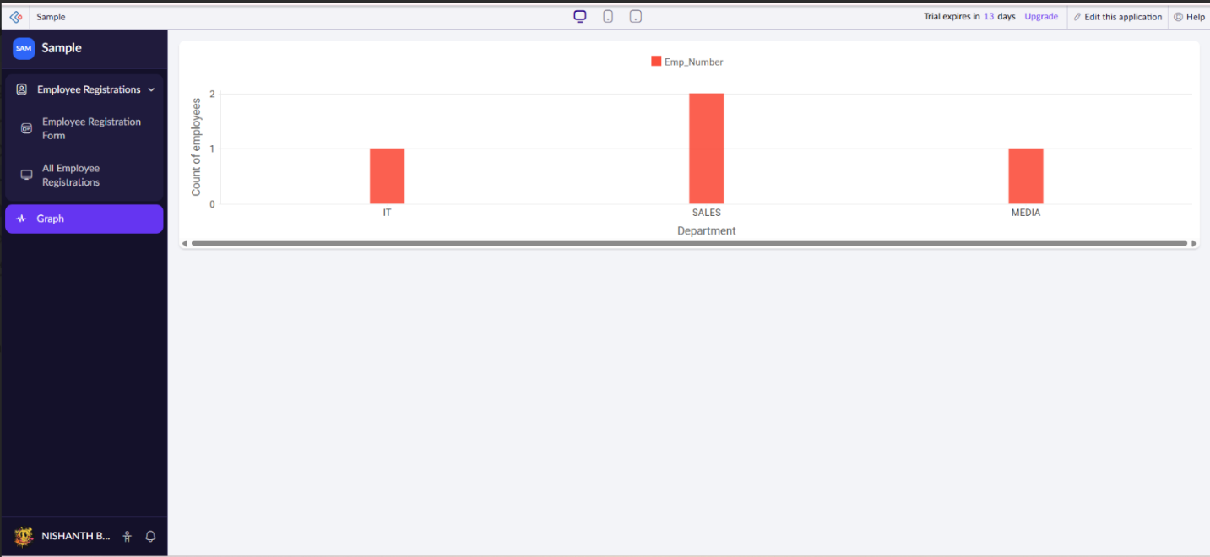
4. Graph

5. Result
Thus, a Zoho Creator account was created successfully. A sample application with a form, report, and dashboard was developed, and the Develop, Deploy, and Manage sections of the Zoho Creator platform were explored successfully.

